Rehearsal Documentation
Part 1 of 3 — Student Modules

Table of Contents

Rehearsal Documentation
Welcome. This is the source-of-truth documentation for Rehearsal by Gradeless.ai — the AI interview rehearsal and career readiness platform.
These docs are written for two audiences at once:
- Students — MBA aspirants, placement candidates, early-career professionals. If you just want to start practicing, jump to Getting Started.
- Faculty — placement cells, professors running GD-PI prep, trainers managing cohorts. Your section starts at Faculty Overview.
If you're reading this inside the in-app help chat, you don't need to worry about any of the structure below — just ask what you want to do.

How to use these docs
Every page follows the same shape, so you can skim fast:
- What it is — one paragraph, plain English
- When to use it — the actual problem it solves
- How to use it — step by step, with a screenshot on any step where the UI matters
- Tips — what the product team actually recommends
- Related — where to go next

Student modules (the six apps)
00 | Getting Started | Sign up, orient yourself, run your first session
01 | Home / Dashboard | Your streak, habits, and daily feed
02 | Your Briefs | 22 story-driven business concept modules
03 | Role Plays | 297 company mock interviews + Custom Upload
04 | Make Resume (CV Enhancer) | Pressure-test your CV before panels do
05 | Aptitude Test | Verbal, LRDI, Quant practice
06 | Ask Coach | AI that remembers your own practice
12 | MCP Connector (coming soon) | External AI assistants connecting to your data
13 | Ambient Recording (coming soon) | Capture real interviews happening in the room

Your account (persistence and analytics)
07 | Notebook | Questions and notes you saved during sessions
08 | History | Every session, every score, your learning curve
09 | Resumes | CVs saved from CV Enhancer
10 | Memories | What Rehearsal remembers about you
— | Account Settings | Profile, password, notifications, subscription

Shared reference
- Pricing and plans
- Scores explained (STAR, Delivery, Change)
- Inside a Role Play — live session walkthrough
- Inside a Brief — reading, MCQs, voice practice
- Microphone & browser permissions
- Mobile vs desktop
- Privacy Policy (summary)
- Glossary
- FAQ and troubleshooting

Faculty section
- Faculty overview
- Requesting access
- Building custom cases and role plays
- Assigning to a class and tracking attendance

Doc status
Each doc has a status: field in its frontmatter:
- complete — reviewed and ready for publishing
- skeleton — structure is in place but needs real content; marked with a ⚠️ banner at the top of the page
The items currently marked skeleton are waiting on screenshots and answers listed in MATERIAL-NEEDED.md.

Doc conventions
- Screenshots — filenames reference the shared asset library (01_home.png, etc.). If you're reading these raw, screenshots live next to the docs in production.
- Paths — page URLs inside Rehearsal are shown like /explore?tab=interviews.
- CTAs — buttons are shown in bold, e.g. Start Role Play, Generate Questions.
- Sidebar references — when we say "the sidebar", we mean the left-hand navigation visible on every page inside the app.

Last reviewed: 22 April 2026. If something here doesn't match what you see in-app, the app is right and this doc is stale — please flag it to the team.

Getting Started with Rehearsal

What it is
Rehearsal is a practice platform for the interviews you're actually going to face — MBA panels, campus placements, GD-PI rounds. It isn't a question bank. You practice by speaking, and the AI listens, scores, and remembers.
Two things make the first ten minutes feel different from other tools:
- You speak. Every interview, brief, and role play is voice-based. Typing isn't the point.
- The AI remembers you. After the first few sessions, it starts referring back to your own transcripts, reports, and memories.

When to use it
Start here if any of the following is true:
- You have a B-school interview or placement round coming up.
- You want to stop rehearsing inside your head and actually hear yourself.
- You're a faculty member setting up cases for your class (skip ahead to the Faculty section).

How to use it

1. Sign up
Go to the app URL your institution shared, or visit the product site directly. Sign up with your email or Google account. You don't need a credit card.
Once you're in, the free tier gives you:
- All 22 Briefs (reading + MCQs + 2 voice practices in total)
- All Aptitude Tests
- Streaks and the habit loop
- 2 voice practice sessions to try before upgrading
If you want unlimited interviews, see Pricing — plans start at ₹59 for a one-day sprint.

2. Land on Home
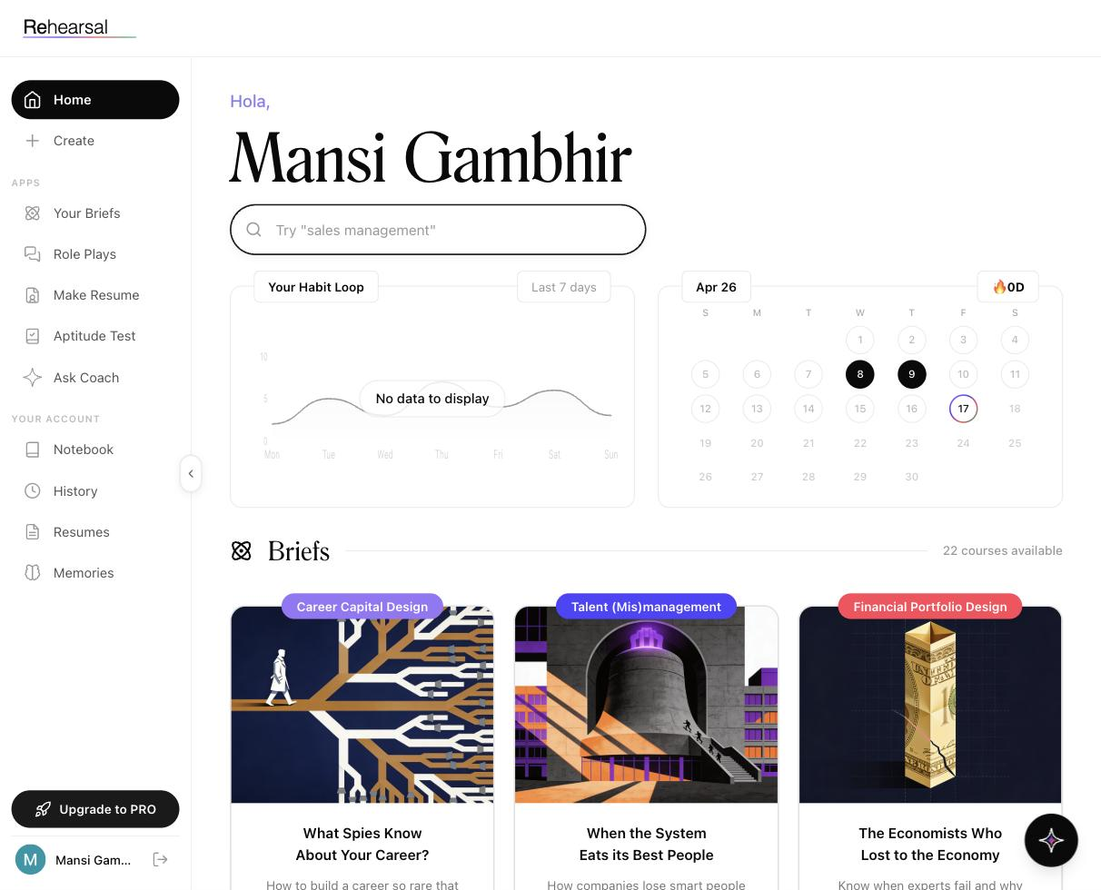
The first thing you see is your dashboard. Read left to right, top to bottom:
- Your greeting — rotates between languages ("Hola, Hello, こんにちは, नमस्ते…"). Just says hi.
- Global search — search across briefs, role plays, companies. Placeholder text rotates through suggestions like "Goldman Sachs" or "portfolio rebalancing".
- Your Habit Loop — a 7-day line chart of your activity. Empty on day one. The point is to see it fill in.
- Streak calendar — monthly view with a flame icon showing how many consecutive days you've practiced. Zero on day one.
- Briefs feed — a scrollable row of the 22 briefs.
- Role Plays feed — visible if you scroll down — the 297 company-specific mock interviews.
The left sidebar is how you navigate. It's the same sidebar on every page.

3. Do one Brief before anything else
New students often go straight to Role Plays because it feels like the main event. Don't. Spend 15 minutes on one Brief first, because:
- Briefs warm up your voice and get you comfortable with the speak-to-the-AI experience.
- Briefs teach the concepts that the Role Play panels will probe.
Pick any brief that catches your eye on the Home feed — the covers and titles are designed to be picked on instinct — and tap Start Brief. See Your Briefs for what happens next.

4. Then do a Role Play
Once one Brief is under your belt, go to Role Plays in the sidebar. Either:
- Pick a real company from the 297 tiles — good if you have a specific interview coming up, or
- Use Custom Upload to drop in a JD and your CV, and Rehearsal generates a personalised role play for that exact job.
Full flow in Role Plays.

5. Check your report
After every session, you get a report with three numbers that matter:
- Overall score (out of 100)
- STAR % — how well-structured your answers were (Situation-Task-Action-Result)
- Delivery % — how you delivered (pace, clarity, confidence)
That's where the real learning lives. See Scores explained for what each number actually measures.

Tips
- Do it out loud, alone in a room. The voice stack picks up mumbling. Speak like you're in the interview.
- Don't chase the score on day one. Your first Overall is a baseline, nothing more. The Change delta on session two is what matters.
- Turn on the Streak early. Two days becomes five becomes a habit. The habit is the product.

Related
- Home — what every widget on the dashboard actually does
- Your Briefs — the 22 story-driven modules
- Role Plays — the 297 company mock interviews
- Pricing — when and why to upgrade

Home / Dashboard

What it is
Home is the landing page every time you open Rehearsal. It's designed to answer two questions the moment you arrive: what is my practice habit looking like? and what should I do right now?


When to use it
- Every time you log in — treat it as the starting line.
- When you want to pick a Brief or Role Play by instinct instead of by search.
- When you want to check your streak before closing the tab for the day.

How to use it

The greeting
The page opens with a rotating greeting (Hola, Hello, こんにちは, नमस्ते, Bonjour…) followed by your name. It's cosmetic. It's there to make the dashboard feel like yours, not a generic tool.

The search bar
Search across briefs, role plays, companies, roles, and sectors from one field. The placeholder rotates through examples — "sales management", "Goldman Sachs", "portfolio rebalancing" — so you see the kind of query that works.
Hits span all six apps, so one search might surface a Brief, a Role Play tile, and an Aptitude topic together.

Your Habit Loop (left card)
A line chart of the last 7 days — Monday through Sunday. Each point is how much you practiced that day. If you've never practiced, the chart says "No data to display" and that's fine; the point of showing an empty chart is to make you want to fill it in.

Streak calendar (right card)
A monthly view. The current day is circled, past practice days are filled in solid black, and the 🔥 counter at the top-right tells you how many consecutive days you've practiced.
Miss a day and the streak resets to 0D. That's deliberate — the pressure is the feature.

Briefs feed
Scroll down and you'll find a row of Brief tiles pulled from the full catalog of 22. Each tile has:
- A category pill at the top (e.g. Career Capital Design, Talent (Mis)management, Financial Portfolio Design).
- A cover illustration — these are hand-designed per brief, not stock.
- A title in serif, usually a question or a provocation ("What Spies Know About Your Career?").
- A one-line hook under the title.
Tap any tile or the Start Brief button to open it.

Role Plays feed
Keep scrolling. Next row is Role Plays — real Indian companies with their four-letter ticker-style codes (ACC for Accenture, ADA for Adani Wilmar, etc.). Each tile shows the company, sector, and role. Tap View Company or the tile itself to open.

Sidebar — always there
The left sidebar is the same on every screen:
- Home (where you are now)
- Create — faculty-only, shows a waitlist screen if you don't have access
- APPS — Your Briefs, Role Plays, Make Resume, Aptitude Test, Ask Coach
- YOUR ACCOUNT — Notebook, History, Resumes, Memories
- Upgrade to PRO — pinned at the bottom
The small AI sparkle icon in the bottom-right of the page is the help chat (this documentation lives in there too).

Tips
- Treat the streak as non-negotiable once you start one. 5 minutes a day is enough to keep it alive — do one Aptitude MCQ if nothing else.
- Don't endlessly scroll the feeds. Pick the first tile that catches your eye and commit. Rehearsal's covers are designed to be chosen on instinct.
- If you're prepping for a specific company, skip the feed and go directly to Role Plays in the sidebar, then search.

Related
- Your Briefs — the full Briefs catalog with all 22
- Role Plays — the full Role Plays catalog
- History — the long-term view of what the streak counter only hints at

Your Briefs

What it is
Briefs are the 22 learning modules at the heart of Rehearsal. Each one takes a business or analytical concept and wraps it in a real story — Palantir, DeBeers, Delhivery, Knight Capital, Madoff, Britannia vs Parle. You read, answer MCQs, and speak into a voice practice.
The point: panels ask you concepts but you have to answer with examples. Briefs give you both at once.
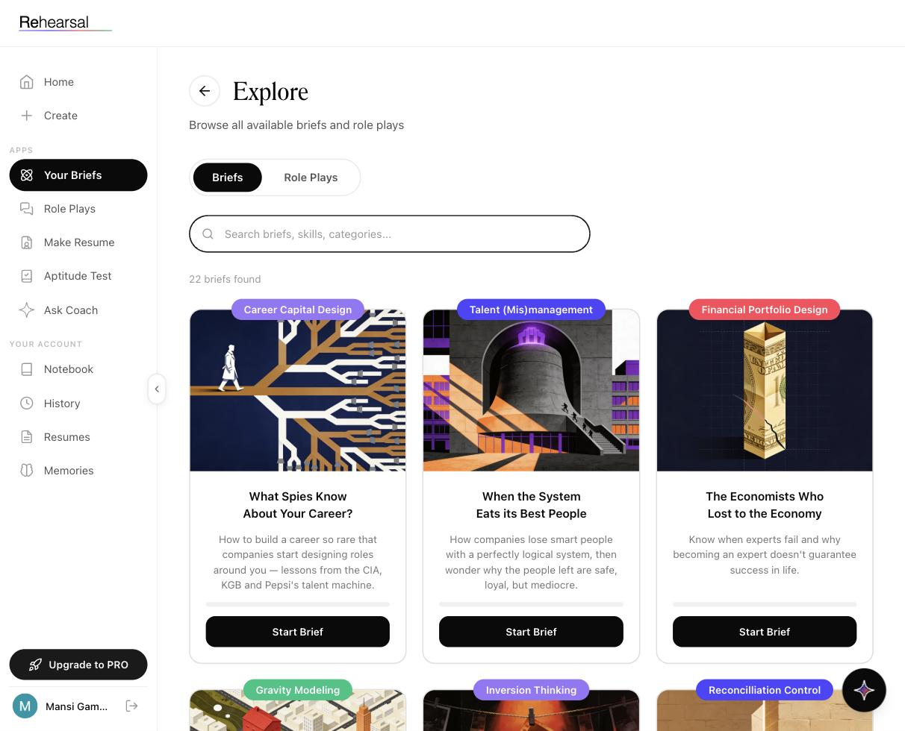

When to use it
- Before Role Plays, always. Briefs warm up both your mental models and your voice.
- When you have 15–20 minutes and want to do something substantive but self-contained.
- When you know a concept is a weak spot (you'll see MBA panels love inversion, second-order thinking, positioning).

How to use it

1. Open the Briefs catalog
Click Your Briefs in the sidebar, or tap Briefs from the toggle on the Explore page. You'll see the count "22 briefs found" and the full grid.

2. Pick a brief
Each brief tile shows four things:
- A colored category pill (e.g. Gravity Modeling, Inversion Thinking, Reconcilliation Control)
- An illustrated cover
- A title (usually a question or a story hook)
- A one-line description that tells you the specific company/story the brief uses
Use the search bar to filter by briefs, skills, or categories.

3. Start the brief
Tap Start Brief on the tile. (If you've already opened the brief before, the CTA becomes Review Brief.)

4. Work through the flow
Inside a brief you'll move through:
- A short read — the story, concept, and frameworks.
- MCQs — to check you caught the point.
- A voice practice — you speak an answer to a prompt based on the brief.
Specific internal lesson structure, quiz scoring, and voice practice flow are being rolled out progressively — what you see in your account is the current version.

5. Use what you learned
After the brief, the concept is in your Memories and Transcripts. Which means:
- Ask Coach can reference it when it critiques your role plays.
- Your Notebook will pick up anything you highlighted.
- Role Plays that touch the same concept will feel less cold.

The full catalog (22 briefs)
Organised the same way they appear in-app, grouped by the kind of problem they prepare you for.

Business & analytical reasoning
- Career Capital Design — What Spies Know About Your Career? — Build a career so rare companies design roles around you. Lessons from the CIA, KGB, and Pepsi's talent machine.
- Talent (Mis)management — When the System Eats its Best People — How companies lose smart people with a perfectly logical system.
- Inversion Thinking — Go Backward to Move Forward — Charlie Munger built $2B thinking inversely. You can train the same.
- Second-Order Thinking — The Bounty that Bred the Plague — Policies that make the problem worse. Catching hidden consequences.
- Gravity Modeling — The Warehouse That Shouldn't Exist — Delhivery's algorithm picked a hub no ops manager would — and cut cost 7.3%.
- Capturing User Intent — Stop Building What Nobody Asked — Hertz spent $32M on a website that never went live.

Finance & economics
- Financial Portfolio Design — The Economists Who Lost to the Economy — When expertise stops protecting you.
- Reconcilliation Control — The Lie and the Glitch — Knight Capital blew up in 45 minutes. Madoff hid for decades. Reconciliation as the guardrail.
- Reading Tax Positions — The Line Between Smart and Criminal — Where tax planning ends and evasion begins, and how to read the line.
- Decoding Financial Products — What They Didn't Teach You About Insurance — 3,300 insurance products in India. Agents sell three. Why.
- Shock Investing — Why Markets Rise When Bombs Fall? — The instinct to sell everything, and why it turns dips into permanent losses.

Strategy, brand, product
- Engineering Belief Systems — The Stain, the Stone, and the Screen — How DeBeers rewired buyer brains at scale.
- Selling Blackbox Products — Sell it like Palantir — How to sell products buyers can't fully evaluate until they're live.
- Corporate & AI Governance — The CEO who tied his own hands — Dario Amodei's guardrail that can fire him.
- Designing for Survival — The Org Chart That Survives a Bomb — Organisations that keep running when the top gets taken out.
- Positioning Warfare — Why Nobody Could Replace India's Favourite Noodle? — Five FMCG brands, one vacancy. Why shelf space isn't positioning.
- Territory Dominance — Why Your Snack's Always In Stock? — Britannia and Parle always in stock; Patanjali often isn't. The planning behind shelf ownership.
- Extending Brands — Why Premium Brands Sell Cheap? — Why cheap grew Apple and shrank Mercedes.

People, automation, interviews themselves
- GenAI Automation — The Task Anatomy — Fewer than 5% of jobs fully automate. 60% have automatable tasks. How to spot them.
- Diagnosing Employee Exits — The Resignation Letter is the Last Symptom — Everyone blames salary. Usually wrong.
- Funnel Recovery — The Leak You're Not Measuring — Why 95 of 100 EdTech leads vanish and the 5-minute window that catches them.
- Defending in HR Interviews — The Honest Answer That'll Cost You The Job — Stop answering HR questions analytically. Answer them like someone who sees the game.

Tips
- One brief per sitting. Finish it fully — read, MCQ, voice practice — before jumping. Half-done briefs don't stick.
- Pick by weakness, not comfort. If finance makes you uneasy, do Reconcilliation Control before you do Positioning Warfare.
- Review Briefs are free passes. They don't use up a paid retake slot the way Role Plays do, so you can replay them as often as you want.

Related
- Role Plays — put the concepts to work in a real interview simulation
- Ask Coach — ask the coach to quiz you on a concept you just read
- Notebook — review highlights and saved questions from briefs

Role Plays

What it is
Role Plays are the mock interviews — the main event. 297 of them, each mapped to a real Indian company and a real role. You pick a company, tap Start Role Play, and speak your way through an interview the AI runs live.
There's also a Custom Upload option: drop a JD and your CV, and Rehearsal generates a role play for that exact opening — same format, personalised.
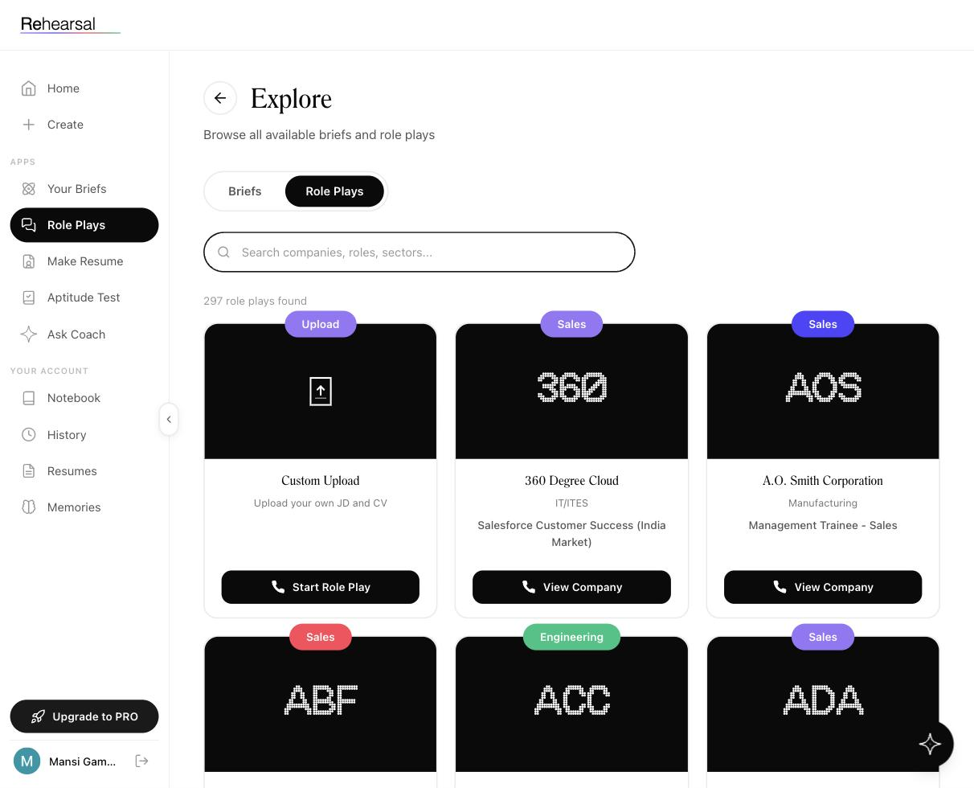

When to use it
- You have a specific company interview coming up — search the tile, practice that one.
- You know the role type but not the company — filter by sector or role (Sales, Engineering, Retail, IT/ITES, Manufacturing, FMCG, Financial Services, IT Services & Consulting).
- You have a JD in hand for a job that isn't one of the 297 — use Custom Upload.
- You're between Briefs and want to see where the concepts break when someone's pushing back on you.

How to use it — picking a company

1. Open Role Plays
Click Role Plays in the sidebar. Or, from the Explore page, toggle from Briefs to Role Plays.
You'll see "297 role plays found" and a grid of tiles.

2. Search or filter
Use the search bar ("Search companies, roles, sectors…") to narrow. Searches match:
- Company names (e.g. Accenture, A.O. Smith)
- Sectors (e.g. FMCG, Financial Services)
- Roles (e.g. Management Trainee - Sales, Software Engineer)

3. Read a tile
Each tile shows:
- A colored sector pill at the top (Sales, Engineering, Retail, etc.)
- A three-letter company code — ACC, ABF, AOS — designed to look like a stock ticker, on a black cover
- Company name in serif
- Sector
- Role title
- A black View Company button (or Start Role Play on the Custom Upload tile)

4. View company → Start role play
Tap View Company to open the company detail page. There you'll see the role context (JD summary, level, sector) and a Start Role Play button. Tap it when you're ready to speak — the session kicks off immediately.

5. During the role play
- It's voice-first. You speak; the AI responds with follow-up questions like a real panel.
- The AI has read your JD and your CV (or the company's default role context if you haven't uploaded one).
- If you've done Briefs, the AI draws from what you learned.
- If you've been using Rehearsal a while, Memories feed into the conversation too.

6. After the role play
You get a report with:
- Overall score out of 100
- STAR % — was your answer structured (Situation–Task–Action–Result)
- Delivery % — pace, clarity, filler words, confidence
- Change delta — improvement vs your last session of a similar role type
Every session also goes to History. Questions you flagged go to Notebook. Themes go to Memories.

How to use it — Custom Upload

1. Open the Custom Upload tile
It's the first tile in the Role Plays grid, marked with a purple Upload pill and an upload icon on a black cover.

2. Tap Start Role Play
The only tile whose CTA is Start Role Play directly (not View Company), because there's no company page — you're creating the session yourself.

3. Provide the JD and your CV
You'll be asked for:
- JD (PDF) — the job description for the role you're targeting
- CV (PDF) — your resume

4. Rehearsal generates the session
The AI reads both documents and builds an interview tailored to the gap between the two — it will press on weak alignment, untested claims on your CV, and specific skill expectations in the JD.

5. Same output as a regular role play
Report, STAR, Delivery, History entry. Custom Upload sessions count the same in your analytics.

Sectors available
Observed sector tags across the 297 role plays:
- Sales
- Engineering
- Retail
- IT / ITES
- Manufacturing
- FMCG / Consumer Durable
- Financial Services
- IT Services & Consulting
- Upload (the Custom Upload tile)
The full directory of 297 companies isn't reprinted here — use in-app search. Featured companies seen at launch include 360 Degree Cloud, A.O. Smith, Accenture, ABFRL (Aditya Birla Fashion & Retail), Adani Wilmar, and Aditya Birla Capital.

Tips
- Do a Brief first on the concept the role will probe. Sales role? Do Positioning Warfare or Territory Dominance first. Consulting role? Inversion Thinking or Second-Order Thinking.
- Your CV goes in the first time. Upload it via CV Enhancer first so Rehearsal has it saved — then every Role Play knows who you are, without you re-uploading.
- Speak like the interview is real. The AI picks up hedging, filler, and over-apology. Your Delivery score is how you'd sound on the day.
- Don't retake immediately. Do a different company or a Brief in between. Back-to-back retakes of the same role teach the AI to prompt you less, which flatters your score and doesn't help.
- Watch the Change delta, not the Overall. Going from 45 → 64 means more than staying at 80.

Related
- CV Enhancer — upload your CV once so every role play is personalised
- History — every session you've run, with the learning curve
- Ask Coach — the AI that's read all your transcripts
- Memories — what Rehearsal is carrying forward about you

Make Resume (CV Enhancer)

What it is

CV Enhancer takes your CV and, optionally, a job description, and generates the stress-test questions a panel would actually ask you based on what's on the page. Not generic HR questions — ones pinned to your specific bullets, your specific numbers, your specific claims.
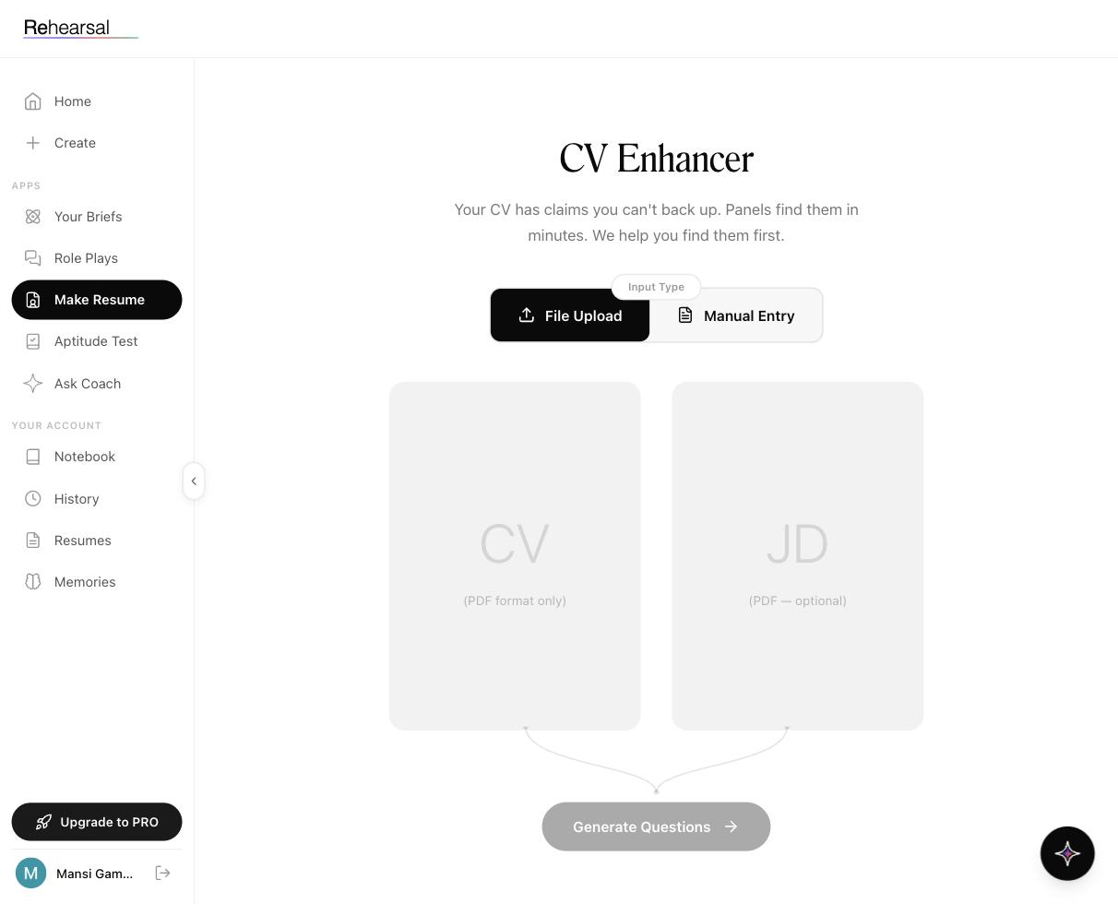

When to use it
- Before any interview where panelists have your CV in front of them.
- When you've just rewritten your CV and want to pressure-test it before sending.
- When a new JD lands and you want to know where your CV doesn't match up yet.
- As a diagnostic: the questions surfaced tell you which bullets on your CV are the weakest.

How to use it

1. Open CV Enhancer
Click Make Resume in the sidebar.

2. Choose your input type
Two options at the top of the page, shown as a pill toggle:
- File Upload (default, black pill) — upload a PDF.
- Manual Entry — paste or type your CV content if you don't have a PDF handy.

3. Upload your CV (required)
In the left drop zone labeled CV (PDF format only), drag and drop or click to select your file.
Rules: - PDF only. - Both file and manual entry flows feed the same engine.

4. Upload a JD (optional but recommended)
In the right drop zone labeled JD (PDF — optional), add the job description for the role you're targeting.
Why you should add it: - With a JD, the generated questions aren't just about your CV in the abstract — they're about the gap between your CV and this specific role. - Without a JD, you get a generic CV stress-test: still useful, just less targeted.

5. Tap Generate Questions
The black pill CTA at the bottom of the page lights up once you've uploaded a CV. Tap it.
The AI reads your CV (and JD, if present), finds the weak points, vague claims, uncheckable numbers, awkward transitions, and produces a list of interview questions a panel would use to probe each one.

6. Review what comes back
You'll get a list of questions grouped by the CV section they attack — work experience, education, projects, skills, leadership. For each question, you can see why it was generated (which bullet triggered it), which is how you diagnose what to rewrite.

7. Do something with it
Two useful next moves:
- Fix the CV. If a bullet generates a question you can't answer cleanly, that bullet needs to be rewritten or removed. Re-upload and re-run.
- Run a Role Play with the same JD. Go to Role Plays → Custom Upload with the same CV and JD and actually practice answering the questions out loud.

Tips
- A good CV surfaces boring questions. A weak CV surfaces interesting ones. If you're reading the question list and thinking "oh god, yeah, they would ask that" — that's the signal to rewrite.
- Run it twice, once per role type. If you're applying to both consulting and product roles, generate questions for each JD separately. The weak spots are different.
- PDF text quality matters. If your CV is a scanned image or has complex multi-column layout, text extraction can miss things. A clean single-column PDF works best.
- Your CV is saved. After the first upload it shows up in Resumes, so you don't need to re-upload every time you start a new role play.

Tier limits
Free and paid tiers have different CV creation quotas:
- Free — 2 CV creations total (one-time)
- Pro — 2 CV creations
- Sprint — 5 CV creations
- Unlimited — unlimited CV creations
See Pricing for the full breakdown.

Related
- Resumes — CVs you've already uploaded, ready to reuse
- Role Plays → Custom Upload — practice answering with the same CV + JD
- Notebook — save questions from CV Enhancer for review

Aptitude Test

What it is

The Aptitude Test module is where you practice the MCQ side of placement and MBA prep: verbal, logical reasoning with data interpretation, and quant. Unlike Role Plays and Briefs, this one isn't voice-based. It's untimed, self-paced drills with bookmarks and accuracy tracking.
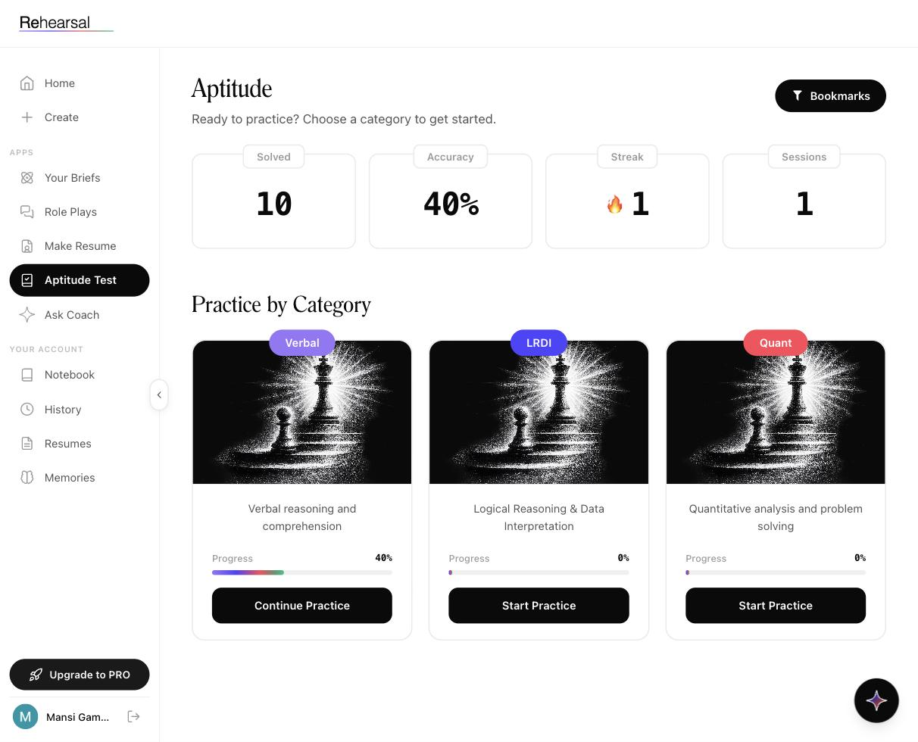

When to use it
- In between voice sessions, to keep the streak alive on low-energy days.
- To plug gaps that Role Play reports flag (if your quant is weak, this is where you fix it).
- For CAT / XAT / campus tests where aptitude MCQs are the bulk of the exam.
- As a warm-up before a consulting case role play — LRDI sharpens the structure you'll need.

How to use it

1. Open Aptitude Test
Click Aptitude Test in the sidebar.

2. Read your dashboard
The top of the page shows four cards:
- Solved — total MCQs you've answered (e.g. 10)
- Accuracy — percentage correct across all sessions (e.g. 40%)
- Streak (🔥) — consecutive days you've done at least one aptitude question (e.g. 1)
- Sessions — total practice sessions started (e.g. 1)
Top-right: a Bookmarks button that opens the questions you've saved for later review.

3. Pick a category
Three category tiles under Practice by Category, each on a black cover with a chess-piece illustration:
- Verbal (purple pill) — verbal reasoning and comprehension
- LRDI (blue pill) — Logical Reasoning & Data Interpretation
- Quant (red pill) — quantitative analysis and problem solving
Each tile shows a Progress bar and percentage specific to that category.

4. Start or continue
- If you've never practiced that category, the button says Start Practice.
- If you have, it says Continue Practice and you pick up where you left off.

5. Answer questions
MCQs appear one at a time. Pick an option, submit, see the explanation. The explanation tells you why — not just which letter was right.

6. Use bookmarks
Any question you want to revisit — because you got it wrong, because the trick is worth remembering, because you guessed — can be bookmarked. They all collect under the Bookmarks button at the top of the dashboard.

7. Save to Notebook
Anything you bookmark can also be saved to your Notebook with your own note attached, which is useful when the trick isn't about the question type but about a specific mistake you keep making.

Categories in detail
Verbal covers reading comprehension, sentence correction, para-jumbles, critical reasoning, vocabulary. Useful for CAT VARC, GMAT Verbal, and general B-school admissions essays.
LRDI is the one most students underprepare for. It's where a consulting firm's guesstimate round secretly lives — the ability to read a table, chart, or caselet and structure an answer under time pressure.
Quant covers arithmetic, algebra, geometry, permutations/combinations, probability, and data sufficiency. Standard placement-test fare.

Tips
- One category per session. Switching between Verbal and Quant mid-session makes your accuracy number meaningless — they measure different things.
- Don't skip the explanation when you got it right. Getting it right by the wrong logic is the dangerous kind of right.
- LRDI is where compounding happens fastest. Twenty minutes a day for two weeks moves the needle more visibly than on Quant.
- The streak counter on Aptitude is separate from Rehearsal's global streak. Doing aptitude still counts toward your platform streak — but the flame on this page is specific to this module.
- Free tier: unlimited. All aptitude practice is available on the free plan. This is a good zero-cost way to sample the product.

Related
- Notebook — save aptitude questions with your own notes
- History — session-level analytics (primarily covers interviews, but aptitude contributes to the streak)

Ask Coach

What it is

Ask Coach is an AI coach that has read everything you've done on Rehearsal — your transcripts, your reports, your memories — and answers questions about you, specifically. It is not a general-purpose chatbot. It's not there to answer "what is STAR?". It's there to answer "where am I losing points?" and mean it.
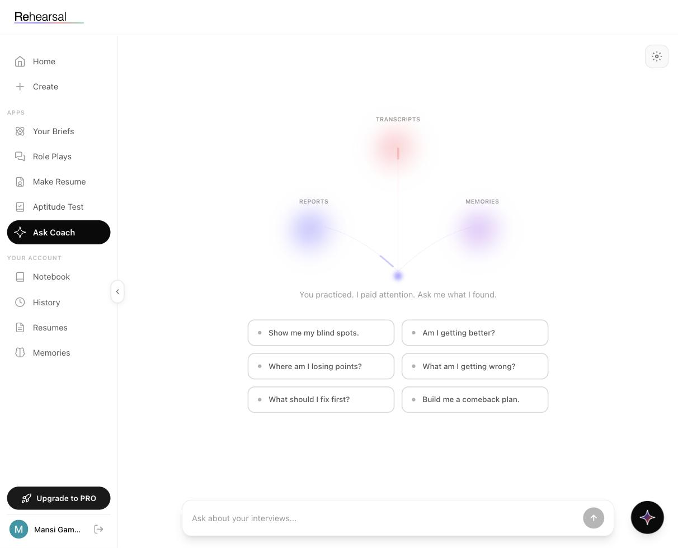

What Ask Coach is not
This is important because students confuse the two:
- Ask Coach is personalised. It only talks about your practice.
- The help chatbot (the AI sparkle icon bottom-right of every page) is where you go for questions about the platform itself — how features work, what a button does, where to find something. That's powered by this documentation.
If you ask Ask Coach "how do I change my password", it won't help. Ask that in the help chat.

When to use it
- After 3+ role plays, when the AI actually has something to compare.
- When a report surprised you — a lower score than you expected, or a higher one — and you want to know why.
- Before your next practice session: "what should I fix first?" is a real, useful question.
- When you want a comeback plan: you've been stuck at the same score for a week, and you want Ask Coach to tell you what to do tomorrow.

How to use it

1. Open Ask Coach
Click Ask Coach in the sidebar.

2. Read the data nodes
The centre of the page shows three glowing nodes connected by faint lines — these are visualisations of where Ask Coach is pulling from:
- Transcripts (top) — everything you said in every session
- Reports (bottom-left) — the scored feedback from every session
- Memories (bottom-right) — see Memories
Below the nodes: the tagline "You practiced. I paid attention. Ask me what I found."

3. Pick a suggested prompt, or type your own
Six suggested prompts are shown as pill buttons:
- Show me my blind spots.
- Am I getting better?
- Where am I losing points?
- What am I getting wrong?
- What should I fix first?
- Build me a comeback plan.
Tap any of them, or type in the Ask about your interviews… input at the bottom.

4. Read the answer
Ask Coach's answer references your specific sessions — not generic advice. You'll see it cite things like "in your Adani Wilmar session on April 9, you…" and point to specific moments.

5. Follow up
It's a conversation. Ask "which session should I re-watch?" or "give me three questions to practice tomorrow on this". It'll use the same context.

How Ask Coach sees you
The six suggested prompts aren't random — they map to what the underlying model is actually good at answering from your data:
Show me my blind spots | Scans transcripts for topics you consistently avoid or answer shallowly
Am I getting better? | Looks at your learning curve and points to concrete score movements
Where am I losing points? | Cross-references low STAR or Delivery scores with specific transcript moments
What am I getting wrong? | Surfaces recurring factual or framework mistakes
What should I fix first? | Ranks weaknesses by impact and how fixable they are
Build me a comeback plan | Creates a 3–5 day practice sequence based on your gaps

Tips
- Give it data to work with. Ask Coach on session one is thin — it has nothing yet. After five role plays it gets genuinely sharp.
- Ask follow-ups in the same thread. The context compounds. "Show me my blind spots" → "okay, which one should I work on tomorrow?" → "build me a 3-day plan for that one" is a real workflow.
- Be specific when vague answers frustrate you. "Where am I losing points?" is general. "Why did I drop from 64 to 51 on session three?" gets a specific diagnosis.
- Use it right before your next session, not right after the last one. Pre-session is when the plan actually changes behaviour.

Tier limits
Ask Coach is message-metered:
- Free — not included
- Pro — 30 messages/month
- Sprint — unlimited
- Unlimited — unlimited
See Pricing.

Related
- Memories — what Ask Coach carries between conversations
- History — the raw session data Ask Coach reads from
- Notebook — where to save answers and action items from Ask Coach

Notebook

What it is
Notebook is where everything you've saved across Rehearsal lives in one place — interview questions you want to revisit, aptitude problems you flagged, key takeaways from briefs. Think of it as your review stack.
It's not automatic. You decide what ends up here.
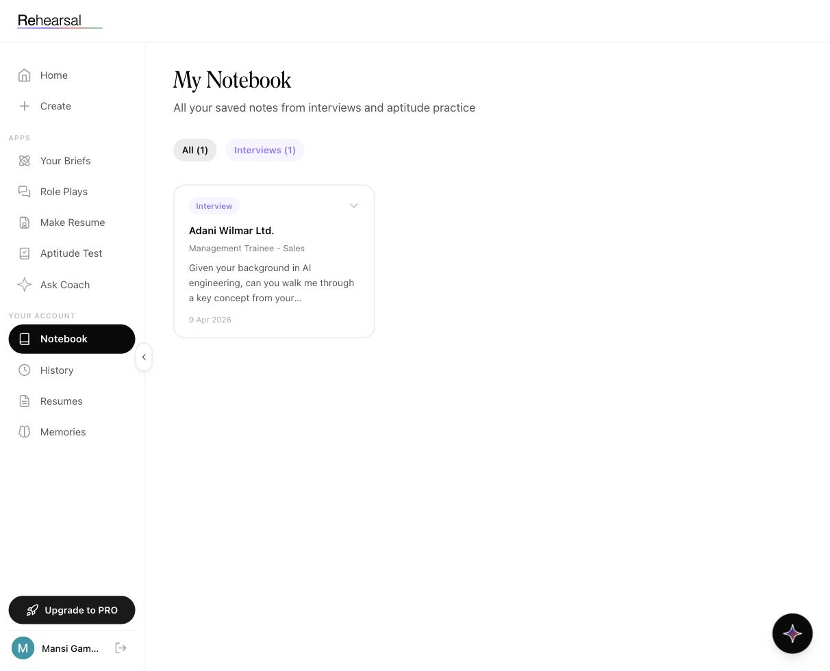

When to use it
- After a role play, to save the question that stumped you — the one you want to draft a better answer for tonight.
- During aptitude practice, for problems with tricks you'll want to see again.
- The night before an interview, to skim every saved question from the relevant role type in one view.
- When Ask Coach gives you an action item worth remembering.

How to use it

1. Saving notes (from other modules)
You don't create notes in Notebook — you create them from wherever you're practicing:
- Inside a Role Play or after the report — flag a question with the save/bookmark control. It lands here with the company, role, and date attached.
- Inside Aptitude Test — bookmark a question. Bookmarks can be pushed to Notebook with your own note.
- Inside a Brief — highlight a concept or note a takeaway.

2. Open Notebook
Click Notebook in the Your Account section of the sidebar.

3. Read the filters
At the top:
- Page title: My Notebook
- Subtitle: "All your saved notes from interviews and aptitude practice"
- Filter pills: All, Interviews, (Aptitude appears when you have aptitude notes). The count next to each pill shows how many notes fall in that bucket — e.g. All (1), Interviews (1).
Tap a filter to narrow the list.

4. Read a note card
Each note appears as a card containing:
- A source type badge (e.g. Interview in light purple)
- The company in bold serif (e.g. Adani Wilmar Ltd.)
- The role in smaller grey (e.g. Management Trainee - Sales)
- The note text — for an interview note, this is typically the question itself with a truncated preview
- The date it was saved (e.g. 9 Apr 2026)

5. Expand a note
Tap the chevron on the right of the card to expand it — you'll see the full question or note text, any context Rehearsal attached (like the session ID or page reference), and any personal note you added.

6. Act on it
Two main things to do with a saved note:
- Draft an answer — have a go at answering the question cold, then bring it to your next role play.
- Ask Ask Coach about it — "walk me through how I should answer this one".

Tips
- Save ruthlessly, prune weekly. Saving is nearly free; keeping 200 notes you'll never reread defeats the point. Once a week, skim and delete the ones that no longer matter.
- Add your own note, not just the question. Saving just a question is fine; saving "I froze on this because I didn't know what segment meant in their context" is useful.
- Filter by Interviews before a company interview. Day-before skim.
- Notebook is structured, not free-form. You can't create a blank note here — everything must originate from a session.

Tier differences
- Free — Notebook is included.
- Pro — Notebook included.
- Sprint / Unlimited — Organized Notebook (categorisation and organisation features beyond the basic list).
See Pricing.

Related
- History — session-level view of everything, not just saved items
- Ask Coach — ask the coach to help you answer a note you saved
- Aptitude Test — where aptitude bookmarks originate

History

What it is
History is where every interview session you've ever run on Rehearsal lives. It's the module that turns a pile of sessions into a learning curve — so you can see whether you're actually getting better, or just busy.
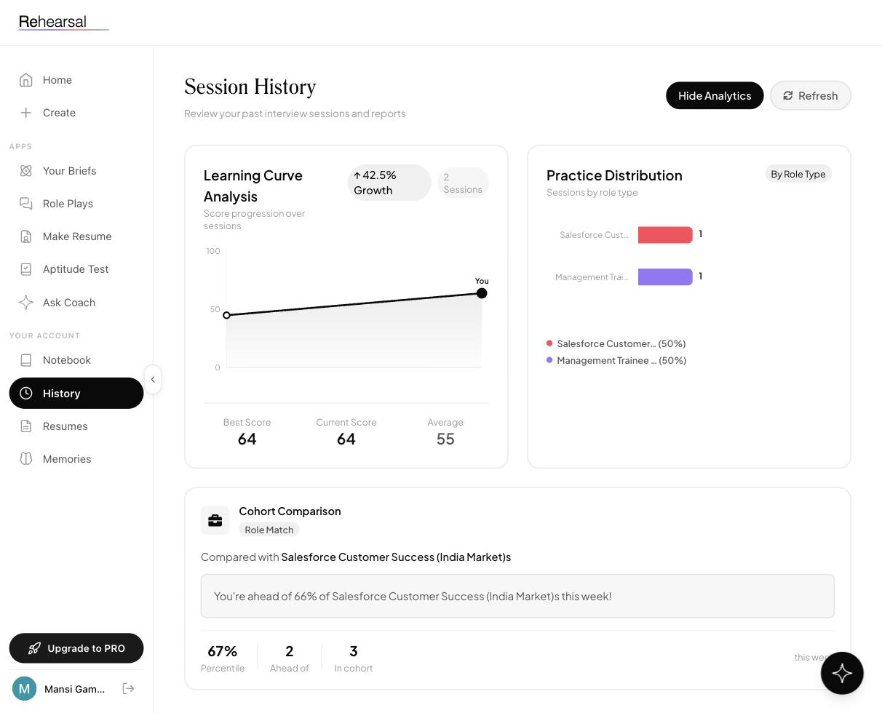

When to use it
- Weekly, to check your Learning Curve and see the direction of travel.
- Before a specific company interview, to pull up your last session of that role type.
- When a report surprises you and you want to compare it to previous sessions of similar roles.
- Before a conversation with Ask Coach, so you know which session numbers to reference.

How to use it

1. Open History
Click History in the Your Account section of the sidebar.

2. Read the header
- Page title: Session History
- Subtitle: "Review your past interview sessions and reports"
- Two controls at the top-right: Hide Analytics (collapses the charts) and Refresh (re-pulls data).

3. Scan the analytics blocks
Three blocks sit above the session table.
Learning Curve Analysis (left) - Score-over-sessions line chart - Growth indicator: "↑ 42.5% Growth" (your improvement since session one) - Session count: e.g. 2 Sessions - Below the chart: Best Score, Current Score, Average — each shown as a big number
Practice Distribution (right) - A chart and legend showing sessions broken down by role type - Example: Salesforce Customer Success (50%) / Management Trainee - Sales (50%) - This tells you whether your practice is diversified or lopsided
Cohort Comparison (full-width, below) - A role-match comparison against other students targeting the same role - Example callout: "You're ahead of 66% of Salesforce Customer Success (India Market)s this week!" - Three stats: Percentile (e.g. 67%), Ahead of (e.g. 2), In cohort (e.g. 3), updated this week

4. Read the session table
Columns (left to right):
Session | Session number (Session 1, Session 2, …)
Date | When you ran it
Role Type | The company/role combination
Overall | Overall score out of 100
STAR | Answer structure score (%)
Delivery | Delivery score (%)
Change | Change vs your previous session of a similar role type
Example row: Session 2 — Apr 09, 2026 — Management Trainee - Sales — Overall 64, STAR 40%, Delivery 89%, Change +19.2.
The first session of any role type has no Change value — there's nothing to compare to.

5. Click a row
Tap any session to open the full report for that session: the transcript, the per-answer scoring, the question-level feedback.

What the analytics are actually telling you
Learning Curve tracks whether your score is trending up. A flat or declining curve after more than three sessions is a signal to change what you practice, not how often.
Practice Distribution tells you whether you've been specialising too narrowly. A 100% pie on one role type before a multi-company placement season is a red flag.
Cohort Comparison is the most underused block. "Ahead of 66%" means 34% of students prepping for the same role are ahead of you — and Rehearsal knows exactly what they're doing differently. Ask Coach can draw from this.

Tips
- Watch Change, not Overall. Change is the per-session improvement metric. Overall can be noisy depending on which role type you drew.
- Don't drop the Refresh button. Reports can take a minute or two to compute after a session ends. If a recent session isn't showing scores yet, click Refresh.
- Hide Analytics when you just want the table. Handy on smaller screens.
- Cohort updates weekly. Your percentile is this week — don't compare to last week's.

Related
- Role Plays — where sessions come from
- Scores explained — STAR, Delivery, and Change in detail
- Ask Coach — conversational analysis of the same data

Resumes

What it is
Resumes is the storage layer for every CV you've ever uploaded to Rehearsal. Upload once; reuse across CV Enhancer runs and Role Plays without re-uploading each time.
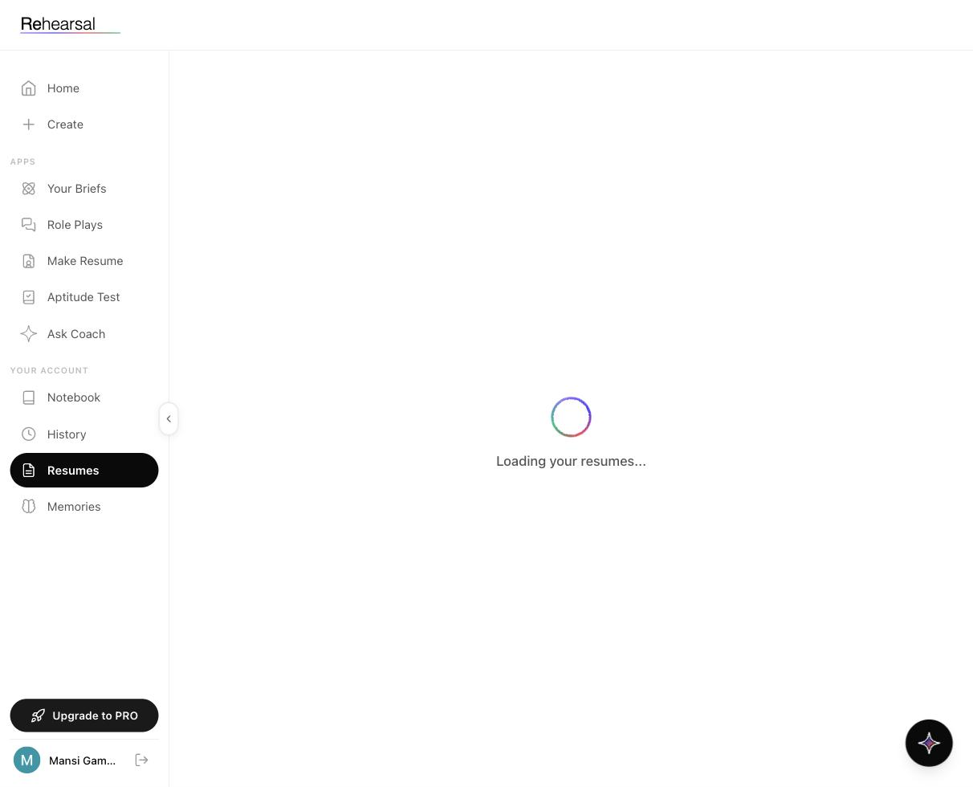

When to use it
- To check which version of your CV Rehearsal has on file before starting a Role Play.
- To delete old CVs that no longer represent you.
- To see how many CV creations you've used against your plan limit.

How to use it

1. Open Resumes
Click Resumes in the Your Account section of the sidebar.

2. Wait for load
On open, the page shows a spinner and "Loading your resumes…" while it pulls your saved CVs from storage.

3. Read the list
Once loaded, you'll see each saved CV as a card. Each shows the filename, the date uploaded, and controls to view, use, or delete it.
If you haven't uploaded a CV yet, the page will be empty — go to [CV Enhancer](./04-cv-enhancer.md) first.

4. Pick a default
If you have multiple CVs, you can set one as your default — that's the one Role Plays will use automatically unless you override it at session start.

Tips
- One CV per role type, not one CV. If you're targeting both consulting and product, keep a separate CV for each and pick the right one per session.
- Prune quarterly. Old CVs bloat your list and risk Rehearsal picking the wrong one for a role play. Delete anything more than two versions back.
- Filenames matter. Rename your CV before uploading — "Resume_Final_v7_REAL.pdf" on your desktop is fine; it's ugly in your Resumes list.
- PDF only. Same constraint as CV Enhancer.

Tier limits
Resumes storage is tied to CV creations:
- Free — 2 CV creations total
- Pro — 2 CV creations
- Sprint — 5 CV creations
- Unlimited — unlimited
See Pricing.

Related
- CV Enhancer — where new CVs are uploaded and analysed
- Role Plays — where saved CVs get used

Memories

What it is

Memories is the AI's long-term context about you. Every five interviews, Rehearsal updates this layer — so your next session, your next report, and your next Ask Coach conversation all know, for example, that you used to work at BCG, that you're targeting consulting, or that you consistently struggle with valuation questions.
Unlike transcripts (which are auto-captured and read-only), Memories are editable. You can add, edit, or delete any of them.
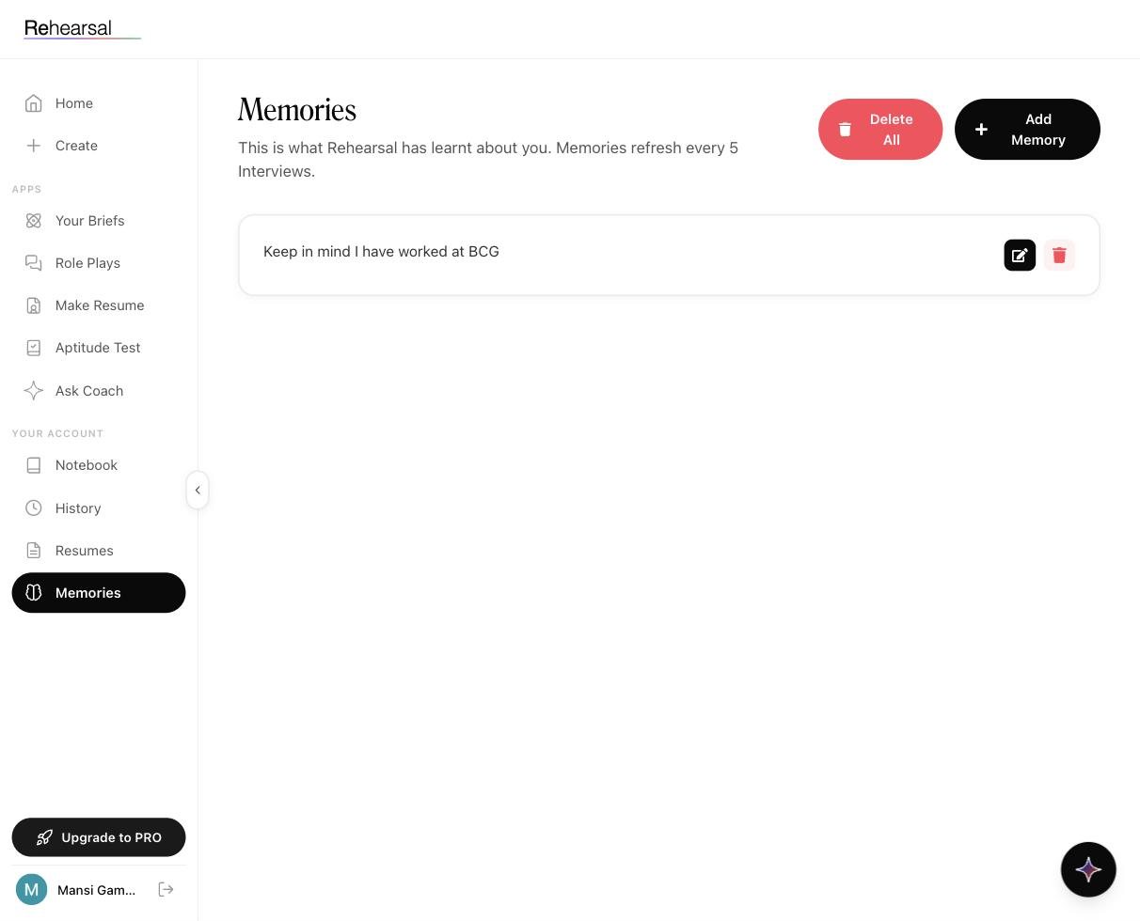

When to use it
- To set the AI's context before your first session, so it doesn't have to infer everything (e.g. "I'm applying to product roles, not consulting").
- After a session where the AI clearly missed something obvious about your background.
- Before a specific interview, to pin down details the AI should not forget ("keep in mind I'm being interviewed for the India market team, not global").
- To prune old memories that no longer represent you.

How to use it

1. Open Memories
Click Memories in the Your Account section of the sidebar.

2. Read the header
- Page title: Memories (serif)
- Subtitle: "This is what Rehearsal has learnt about you. Memories refresh every 5 Interviews."
- Two buttons at the top-right: Delete All (red pill, left) and Add Memory (black pill, right).

3. Read existing memories
Each memory is a card showing the text of the memory, with two icons on the right:
- Edit (pencil, black button) — rewrite the memory in place.
- Delete (trash, red button) — remove the memory.
Example memory: "Keep in mind I have worked at BCG".

4. Add a memory
Tap Add Memory. A field opens where you type in a short, declarative statement — one sentence is best.
Good examples: - "I am targeting Sales Leadership roles at FMCG companies in India." - "I hold an engineering degree but am pivoting to consulting." - "Focus me on weaknesses in quantitative analysis — that's where I lose most points."
Bad examples: - "Help me." (too vague) - Three paragraphs of life history (too long; memories are short tags)

5. Edit or delete anytime
Tap the pencil icon to rewrite. Tap the trash to remove. Nothing is permanent.

6. Let the system update itself
After every 5 interviews, Rehearsal writes new memories on its own based on what it learned. You'll see these appear automatically. Edit or delete them if they're wrong — the AI does guess, and you're the correction layer.

How memories actually affect the product
Memories feed into:
- Role Plays — the interviewing AI reads your memories before the session and tailors questions around them.
- Ask Coach — treats memories as ground truth about your background (along with transcripts and reports).
- Reports — framings in feedback reference your memories ("given your BCG background…").
Memories don't affect:
- Briefs (same content for everyone).
- Aptitude Test (neutral).

Tips
- Seed 3–5 memories before your first real Role Play. Target role, target sector, background, known weakness. That's it.
- Keep each memory to one sentence. The shorter and more declarative, the more reliably the AI uses it.
- When an AI-written memory is almost right but not quite, edit it — don't delete and rewrite. Editing preserves the "this was learned from session X" signal.
- Delete memories that stop being true. If you finish a switch into product and the memory still says "targeting consulting", you'll get the wrong role play prep.
- Don't use memories for temporary instructions. "Today I'm practicing for Adani Wilmar" is a today-thing, not a forever-thing. Start the role play directly instead.

Related
- Ask Coach — one of the three data sources (Transcripts, Reports, Memories)
- Role Plays — where memories most visibly affect the experience

Pricing and Plans

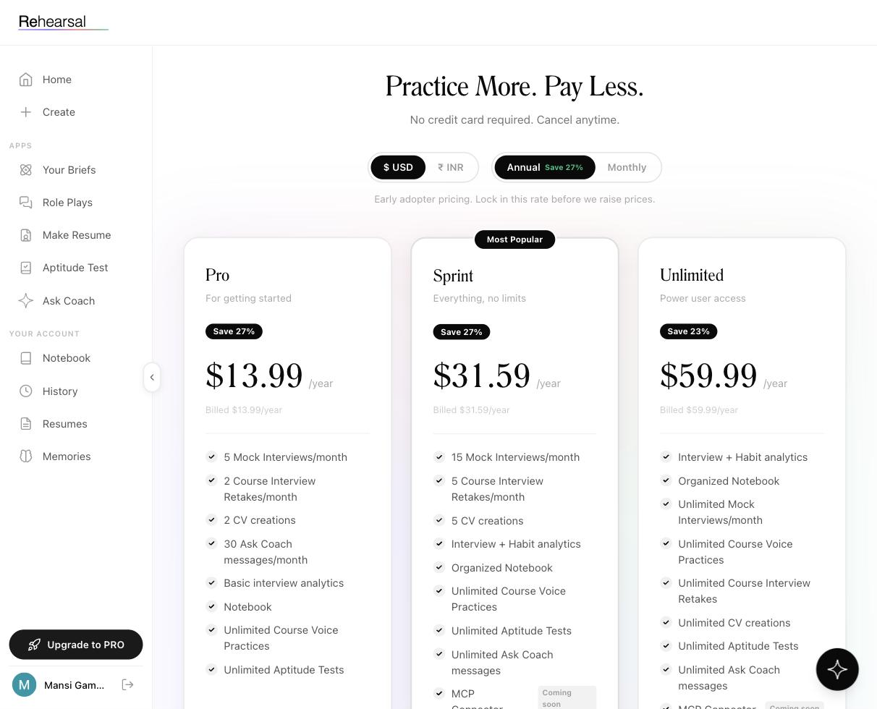

What it is
Rehearsal offers two distinct pricing tracks for very different use cases:
- INR short-duration bursts — for students who want focused practice ahead of a specific interview window. Starts at ₹59 for a single day.
- USD annual tiers — for long-term use, priced by the year with headline-low numbers.
Plus a free tier that never expires.
You can switch between $ USD and ₹ INR using the currency toggle at the top of the pricing page, and between Annual (Save 27%) and Monthly using the billing toggle.

Free forever
No card. No trial countdown.
Included: - All 22 Briefs (reading + MCQs) - All Aptitude Tests (Verbal, LRDI, Quant) - Streaks and Habit Loop - 2 voice practice sessions (across Briefs and/or Role Plays combined) - Notebook (basic)
Not included: - Ask Coach - Unlimited Role Plays - Multiple CV creations - Advanced analytics
Who it fits: anyone exploring whether Rehearsal is the right tool before committing.

INR plans — short bursts
Designed for Indian students who have a clear interview window and want intense practice for that window, not a yearly subscription.
Introductory | ₹59 | 1 day | 5 | 2 | Email
3-Day Plan | ₹159 | 3 days | 15 | 3 | Priority
Weekly Plan | ₹229 | 7 days | 25 | 5 | Priority
3-Week Sprint | ₹349 | 21 days | Unlimited | 7 | Premium
Yearly Plan | ₹3,499 | 365 days | Unlimited | Unlimited | Premium (save 70%)
Who each fits: - ₹59 — you have an interview tomorrow, want to cram a handful of role plays tonight. - ₹159 — a long weekend of prep. - ₹229 — a single placement-heavy week. - ₹349 — a full placement season sprint with unlimited interviews. - ₹3,499 — the year-long plan if you're deep in prep (CAT through placements).

USD tiers — annual
Three tiers, all billed yearly. Prices shown are annual totals, not monthly.
### Pro — $13.99/yr (Save 27%) For getting started
- 5 Mock Interviews/month
- 2 Course Interview Retakes/month
- 2 CV creations
- 30 Ask Coach messages/month
- Basic interview analytics
- Notebook
- Unlimited Course Voice Practices
- Unlimited Aptitude Tests
### Sprint — $31.59/yr (Save 27%) — Most Popular Everything, no limits
- 15 Mock Interviews/month
- 5 Course Interview Retakes/month
- 5 CV creations
- Interview + Habit analytics
- Organized Notebook
- Unlimited Course Voice Practices
- Unlimited Aptitude Tests
- Unlimited Ask Coach messages
- MCP Connector (Coming soon)
### Unlimited — $59.99/yr (Save 23%) Power user access
- Interview + Habit analytics
- Organized Notebook
- Unlimited Mock Interviews/month
- Unlimited Course Voice Practices
- Unlimited Course Interview Retakes
- Unlimited CV creations
- Unlimited Aptitude Tests
- Unlimited Ask Coach messages
- MCP Connector (Coming soon)

Which plan should you pick?
A quick guide by situation:
Just exploring | Free
Interview tomorrow | ₹59 Introductory
B-school placement week | ₹229 Weekly or ₹349 3-Week Sprint
Full placement season | ₹349 3-Week Sprint (unlimited) or ₹3,499 Yearly
Prepping across CAT + placements | ₹3,499 Yearly or Unlimited USD
Want Ask Coach always available | Sprint or Unlimited (USD)
Managing a class (faculty) | Contact via Faculty Request Access

MCP Connector (coming soon)
Listed on Sprint and Unlimited. This is the upcoming Model Context Protocol integration that will let external AI assistants (like Claude or ChatGPT desktop apps) connect to your Rehearsal data — so you can ask your own AI assistant about your Rehearsal practice directly. Status: in development.

Things to know before you upgrade
- No credit card on free. Upgrades do need payment, but no hidden trial card.
- Cancel anytime. Monthly and annual subscriptions can be cancelled from account settings; access runs to the end of the billing period.
- Early adopter pricing. The footer note isn't marketing fluff — prices are genuinely subject to increase, so locking in an annual at current rates is worth considering.
- Prices include applicable taxes.

Related
- Getting Started — start free, upgrade when you need to
- Role Plays — the feature most affected by plan limits
- Ask Coach — message limits differ sharply between tiers

MCP Connector (Coming Soon)

What it is
The MCP Connector is an upcoming integration built on the Model Context Protocol — an open standard that lets external AI assistants (Claude Desktop, ChatGPT desktop app, Cursor, and other MCP-aware tools) connect directly to your Rehearsal data.
In plain terms: your own AI assistant will be able to talk about your Rehearsal practice without you copy-pasting transcripts.

Who it's for
- Students who already use an AI assistant heavily in their workflow and want their Rehearsal practice data to be part of that context.
- Power users who want to query their own history with custom prompts not available in Ask Coach.

Expected use cases
Once released, likely patterns:
- "Summarise my last five consulting role plays and build me a prep plan for tomorrow's case round." — asked in Claude Desktop, answered using Rehearsal's MCP connection.
- "Compare my scores on Sales role plays vs Product role plays" — asked in any MCP-aware assistant.
- "Draft a CV bullet based on what I practiced in my ABFRL role play."

Plans that include it
MCP Connector is listed on:
- Sprint ($31.59/yr) — Coming soon
- Unlimited ($59.99/yr) — Coming soon
It's not listed on Pro or on any of the INR burst plans.

What we know is coming vs not
All of this is subject to change until launch.
Likely: - A standard MCP server endpoint Rehearsal users can point their assistant to. - Auth via a token tied to your Rehearsal account. - Read-only access to Transcripts, Reports, and Memories (the same data Ask Coach sees).
Unconfirmed: - Whether write access is in scope (e.g. adding a memory from an external assistant). - Which specific AI assistants / MCP clients will be officially supported at launch. - Latency and rate limits.

Where this fits alongside Ask Coach
- Ask Coach — inside Rehearsal, the intended default way to talk to your practice data.
- MCP Connector — outside Rehearsal, for integrating your practice data into your existing AI workflow.
Both pull from the same underlying data (Transcripts, Reports, Memories).

Status
Not released yet. This doc is a placeholder; update once the feature ships.

Related
- Ask Coach
- Pricing
- Memories

Ambient Interview Recording (Coming Soon)

What it is
Ambient Interview Recording will use Rehearsal's existing voice stack to capture and analyse real interviews happening between two people in the room — for example, a student practising with a trainer, or (where allowed) a real placement interview. Output will be similar to a standard Role Play report: speaker-attributed transcript, scoring, and ideal-answer suggestions.
Inspiration / comparable products: NeoSapien, Plaud.

Who it's for
- B-school placement candidates — capture the questions a company actually asked in the real interview room (where phones are allowed on silent).
- Students practising with trainers — skip the mock interview platform and just record the live session; get a Rehearsal-style report afterward.
- Faculty running mock panels — capture a whole class's worth of mock interviews in one pass.

Core concept
- Mobile phone records the conversation in the room.
- Speaker diarisation separates Speaker 1 / Speaker 2 automatically.
- The AI processes the audio and produces a Rehearsal-style report.

Known constraints
Flagged during roadmap discussion:
- Corporate interview rooms — some companies (Deloitte, BlackRock were mentioned) require phones to be kept outside the interview room. In those cases, this feature can't be used.
- B-school interviews generally allow phones on silent mode — this is the primary target use case.
- Engineering college interviews may have stricter monitoring.
- Ambient noise handling — the product team has flagged this as a major technical challenge to solve before launch.

Planned distribution
The feature is expected to be offered free or heavily discounted initially, with the goal of collecting diverse company-interview data that feeds the question library.

Use cases the team is designing for
- Student uses it during a mock interview with their college's placement trainer → gets a report after.
- Student uses it during a real company interview (where allowed) → gets a report after + the questions are added to the Rehearsal corpus for other students.
- Faculty uses it during a class-wide mock panel day → every student walks away with a report.

Status
Not released yet. Technical challenges (noise filtering, diarisation accuracy) are being worked through. This doc is a placeholder and should be replaced with the real feature docs at launch.

Related
- Role Plays — the existing in-platform voice practice this will extend
- Faculty Overview — probable faculty-side use case

Account Settings

What it is
The Account Settings area is where you manage your login, profile, notification preferences, subscription, and account deletion. It's typically accessed from your profile avatar or name at the bottom of the sidebar.

When to use it
- Change your password or email
- Update your display name or profile picture
- Manage email / in-app notification preferences
- View or change your subscription plan
- Download your data
- Delete your account

How to use it

Accessing Account Settings
Needs: the exact path. Probably clicking the user avatar (Mansi Gam…) at the bottom-left of the sidebar, then a menu option.

Profile
Needs: screenshot + exact fields (name, email, profile picture, institution?).

Password & security
Needs: password change flow, whether 2FA is supported, whether there's Google SSO login.

Notifications
Needs: which events can trigger notifications (assigned case, report ready, Ask Coach reply?), which channels (email, in-app, push if mobile).

Subscription
Needs: where users see their current plan, how to upgrade/downgrade/cancel, how to update payment method, where invoices live.

Data & privacy
Needs: download-your-data flow (if any), account deletion flow, and the copy Rehearsal uses around audio retention (tied to the privacy policy update in progress).

Logout
Clicking the logout icon next to your name in the sidebar signs you out of the session.

Tips
To be written once the actual settings are documented.

Related
- Pricing — plan details
- Privacy Policy — what Rehearsal stores about you

